Summer Workshop 2026, SCA, KIIT University
Assignment 1 Submission
Agentic AI-Based Intelligent File Tracking, Workflow Prediction, Delay Detection, and Smart Administrative Routing System
Name: Ayush Raj
Department: School of Computer Science & Engineering, KIIT University
Email: 23051582@kiit.ac.in

Problem Being Solved by the Proposed System
In universities, government offices, hospitals, enterprises, and administrative organizations, files frequently move through multiple departments for verification, approval, processing, and completion. Existing file management systems often suffer from several problems:

- Lack of real-time visibility regarding file location.
- Delays due to manual routing and approval processes.
- Difficulty in predicting completion timelines.
- Absence of accountability for delayed processing.
- Repeated manual follow-up by users.
- Unauthorized routing or workflow deviations.
- No intelligent prioritization of urgent files.

For example, a scholarship approval request in a university may pass through multiple offices. Students often have no visibility regarding its status, expected completion time, or reason for delay. Administrative staff must manually track files, resulting in inefficiency and reduced productivity.

Therefore, there is a need for an intelligent system capable of tracking file movement, predicting delays, optimizing routing, and improving transparency throughout the workflow lifecycle.

Proposed Solution
The proposed system is an Agentic AI-powered Intelligent File Tracking and Workflow Prediction Platform that autonomously manages the movement of files across departments.

The system uses multiple specialized AI agents to monitor file status, predict completion times, identify bottlenecks, and recommend optimized routing paths.

System Workflow

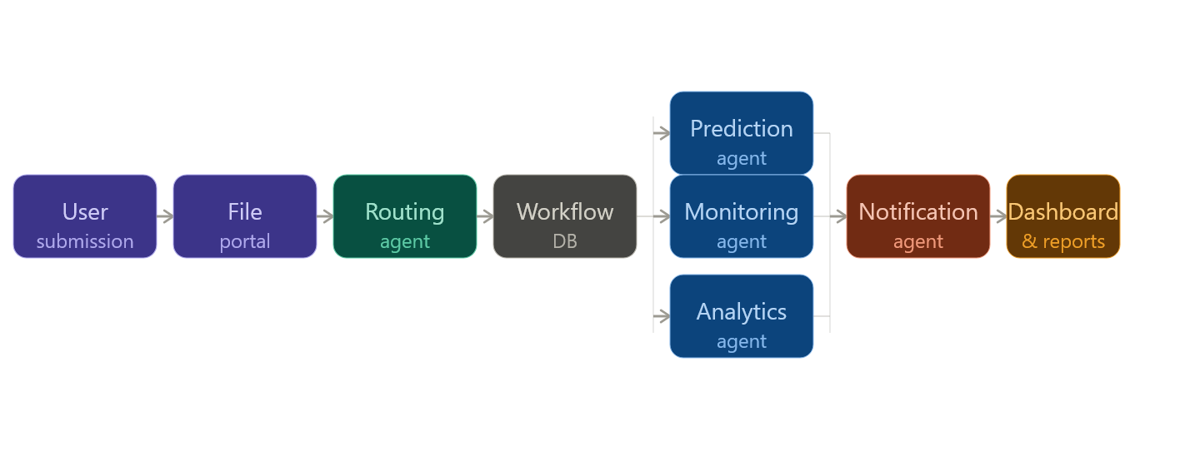Components

Routing Agent
- Determines the correct workflow path.
- Validates routing rules.
- Prevents unauthorized movement.

Prediction Agent
- Estimates completion time.
- Predicts probability of delays.
- Forecasts bottlenecks.

Monitoring Agent
- Tracks inactivity.
- Detects workflow stagnation.
- Sends automated reminders.

Analytics Agent
- Generates performance reports.
- Identifies inefficient departments.

Notification Agent
- Sends alerts through Email, SMS, and App Notifications.

Dashboard
- Provides real-time tracking.
- Displays workflow status.
- Shows delay predictions.

Existing Solutions
Several workflow and file-tracking solutions currently exist:

Existing Solution | Features | Limitations
ERP Systems | File tracking | Limited prediction capability
Document Management Systems | Storage and movement logging | No intelligent routing
Government e-Office Platforms | Digital approvals | Lack predictive analytics
Workflow Management Software | Process automation | Limited AI integration
Traditional Manual Systems | Human-controlled | Slow and error-prone

Most existing solutions only record file movement. They do not actively understand workflow behaviour or predict future outcomes.

Uniqueness of the Proposed Solution
The proposed system differs from existing solutions in several ways:

AI-Based Completion Prediction
The system estimates expected completion time using historical workflow data.

Intelligent Routing
The AI automatically suggests optimal forwarding paths.

Delay Detection
The system identifies bottlenecks before significant delays occur.

Multi-Agent Architecture
Different AI agents handle routing, prediction, monitoring, analytics, and communication independently.

Conversational AI Assistant
Users can ask: Where is my file? Why is it delayed? When will it be completed? — and receive intelligent responses.

Adaptive Learning
The system continuously improves prediction accuracy using workflow history.

Advantages of the Proposed Solution
Feature | Conventional Systems | Proposed System
File Tracking | Basic tracking | Real-time intelligent tracking
Delay Detection | Manual | Automatic
Completion Prediction | Not Available | AI-based prediction
Routing | Manual | Intelligent routing
Notifications | Limited | Automated multi-channel alerts
Analytics | Basic | Advanced predictive analytics
Transparency | Moderate | High
Accountability | Limited | Comprehensive
Scalability | Moderate | High

Economic Potential
The system can be deployed in:
- Universities
- Government offices
- Corporate organizations
- Hospitals
- Banks
- Research institutions

Organizations can reduce administrative costs, improve efficiency, and enhance service delivery.

Alternative Approaches
Alternative methods include:

Manual Tracking
Staffs manually update file status.
Limitation: High workload and human error.

Rule-Based Systems
Predefined workflow rules are followed.
Limitation: Lack flexibility and prediction capability.

Traditional Workflow Software
Automates movement but lacks intelligence.
Limitation: Cannot predict delays.

Human Supervision Only
Administrators monitor progress manually.
Limitation: Not scalable for large organizations.

Compared to these approaches, the proposed system combines automation, prediction, and intelligence.

Novel Aspects of the Work
The major innovations include:

Agentic AI-Based Workflow Management
Multiple AI agents collaborate to manage workflows.

Predictive Completion Estimation
Machine learning models estimate completion timelines.

Dynamic Bottleneck Detection
The system proactively identifies delays.

Smart Escalation Framework
Delayed files automatically trigger reminders and escalations.

AI Priority Classification
Files are automatically categorized as: Critical, High Priority, Normal, Low Priority.

Natural Language Query Interface
Users interact using conversational language.

Workflow Intelligence Engine
Learns from historical data to optimize future routing decisions.

Environmental Issues
The system is primarily software-based and has minimal environmental impact.

Potential concerns include:
- Electricity consumption by servers.
- Cloud computing energy usage.
- Data storage requirements.

Mitigation measures:
- Cloud optimization.
- Energy-efficient server infrastructure.
- Scheduled resource scaling.
- Efficient machine learning models.

Overall environmental impact remains significantly lower than paper-based administrative systems.

Innovative Features
The proposed system incorporates the following advanced features:
- Real-Time File Tracking
- AI Completion Time Prediction
- Intelligent Workflow Routing
- Automated Delay Detection
- Smart Escalation System
- Department Performance Analytics
- Heat map-Based Bottleneck Visualization
- AI-Powered User Assistant
- Automated Notifications
- Dynamic Priority Assignment
- Unauthorized Routing Detection
- Duplicate File Detection
- Adaptive Machine Learning Optimization
- Comprehensive Audit Logs
- Dashboard-Based Monitoring

These features collectively create a sophisticated administrative intelligence platform.

Utilities and Applications
The proposed system can be applied in:

Educational Institutions
- Scholarship approvals
- Student applications
- Examination workflows

Government Offices
- Public service requests
- Administrative approvals

Healthcare
- Patient document workflows
- Insurance approvals

Corporate Organizations
- HR approvals
- Procurement workflows
- Internal document processing

Banking Sector
- Loan approvals
- Compliance workflows

Research Institutions
- Grant approvals
- Research proposal management

Legal and Judicial Systems
- Case file tracking
- Document movement monitoring

Smart City Administration
- Public service management
- Infrastructure approval workflows

Conclusion
The proposed Agentic AI-Based Intelligent File Tracking, Workflow Prediction, Delay Detection, and Smart Administrative Routing System transforms traditional file management into an intelligent, predictive, and autonomous workflow ecosystem. By integrating Agentic AI, machine learning, predictive analytics, and automated routing, the system improves transparency, efficiency, accountability, and decision-making. The solution has strong commercial potential and can significantly enhance administrative operations across multiple domains.

References
[1] Workflow Management System (WfMS) Overview
https://en.wikipedia.org/wiki/Workflow_management_system
[2] Process Mining – Communications of the ACM
https://cacm.acm.org/research/process-mining/
[3] A Comprehensive Survey of Process Mining and Predictive Analytics
https://arxiv.org/html/2301.10398v2
[4] Next Step Recommendation and Prediction Based on Process Mining Techniques
https://dl.acm.org/doi/10.1145/2723839.2723842
[5] The Effectiveness of Workflow Management Systems: Predictions and Lessons Learned
https://www.researchgate.net/publication/229124787_The_Effectiveness_of_Workflow_Management_Systems_Predictions_and_Lessons_Learned
[6] Mining Process Models from Workflow Logs
https://dl.acm.org/doi/10.5555/645338.650397
[7] Process Mining: Data Science in Action
https://www.researchgate.net/publication/312596129_Process_Mining_Data_Science_in_Action
[8] PMPCO: A Process-Mining-Enhanced Deep Learning Framework
https://dl.acm.org/doi/10.1145/3777577.3777698
[9] Scientific Workflows for Process Mining: Building Blocks and Analysis Scenarios
https://dl.acm.org/doi/10.1007/s10009-015-0399-5
[10] Developing a Workflow Management System Simulation for Cloud Environments
https://link.springer.com/article/10.1007/s10723-022-09638-7
[11] Process Mining Research Portal – Eindhoven University of Technology
http://www.processmining.org
[12] Workflow Management Coalition (WfMC)
https://www.wfmc.org
[13] A Workflow Management System Guide
https://arxiv.org/abs/2212.01422
[14] Pegasus Workflow Management System
https://pegasus.isi.edu
[15] Scientific Workflow Systems Overview
https://en.wikipedia.org/wiki/Scientific_workflow_system
[16] Kepler Scientific Workflow System
https://en.wikipedia.org/wiki/Kepler_scientific_workflow_system
[17] Inductive Miner – Process Discovery Algorithm
https://en.wikipedia.org/wiki/Inductive_miner
[18] IEEE Task Force on Process Mining
https://www.tf-pm.org
[19] Business Process Management and Workflow Automation Research
https://www.springer.com/gp/book/9783662498507
[20] Process Mining and Workflow Intelligence Applications in Organizations
https://arxiv.org/abs/2510.25935

